**3 Tier With Load Balancers**

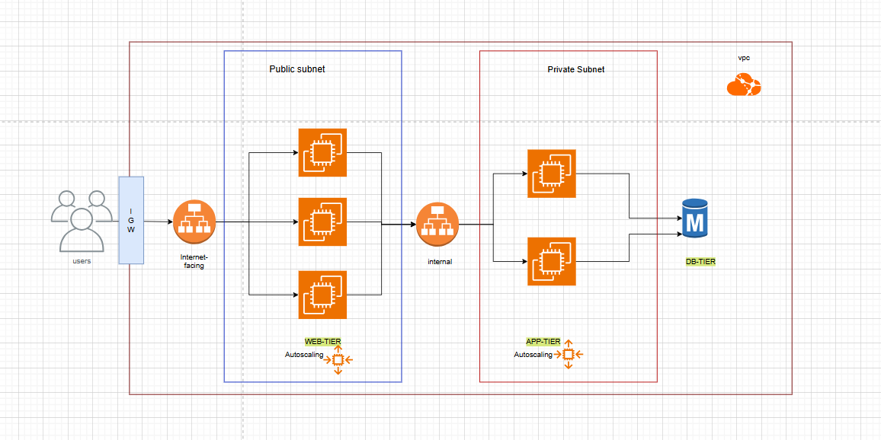

**Step 1. Login to AWS**

Go to AWS account -> Login with your credentials

**Step 2. VPC , Subnet , Internet Gateway and Route Table**

**1]** Create a **VPC**: CIDR: 10.0.0.0/16

**2]** Create three **subnets**:

* + Web Subnet: 10.0.0.0/20 🡪 Public
  + App Subnet: 10.0.16.0/20 🡪 Private
  + App Subnet2: 10.0.32.0/20 🡪 Private

**3]** Create an **Internet Gateway** and attach it to the VPC.

**4] Route Table** :

* Add (0.0.0.0/0 -> IGW ) entry in RT created with VPC 🡪 Public Route Table
* Create a Custom Route Table without igw. 🡪 Private Route Table
* Associate public route table 🡪 Web Subnet
* Associate private route table 🡪 Both app subnets

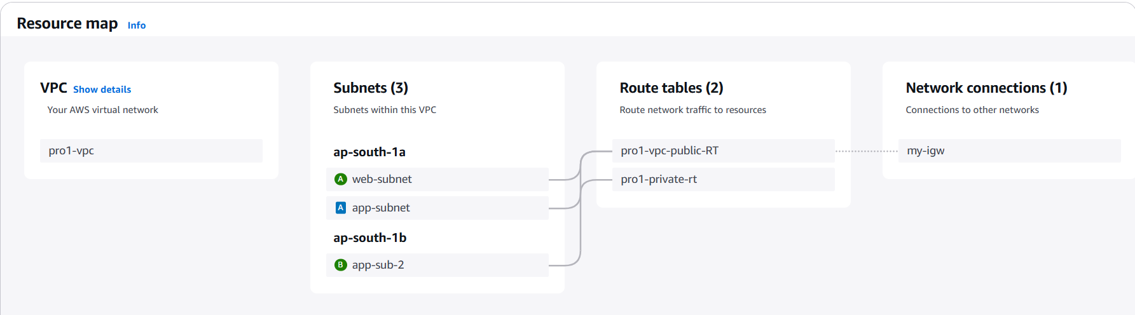

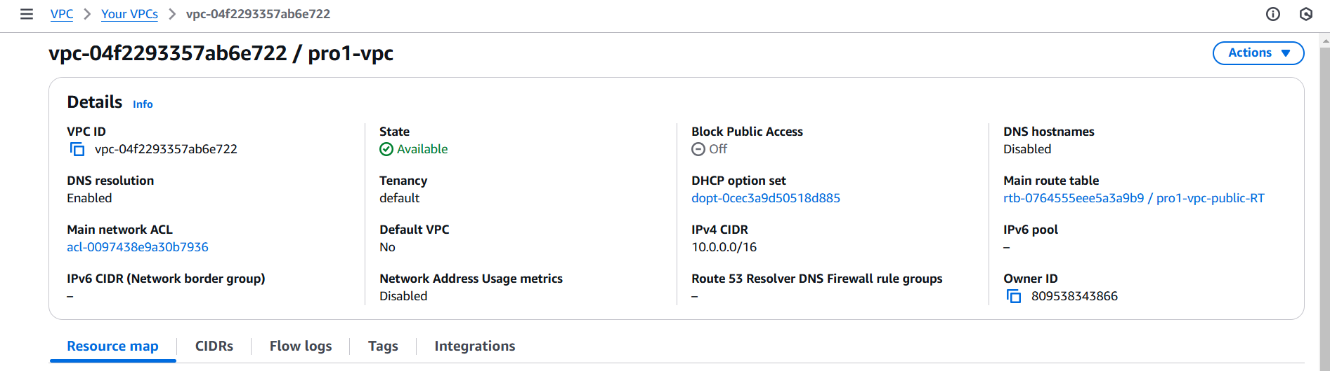

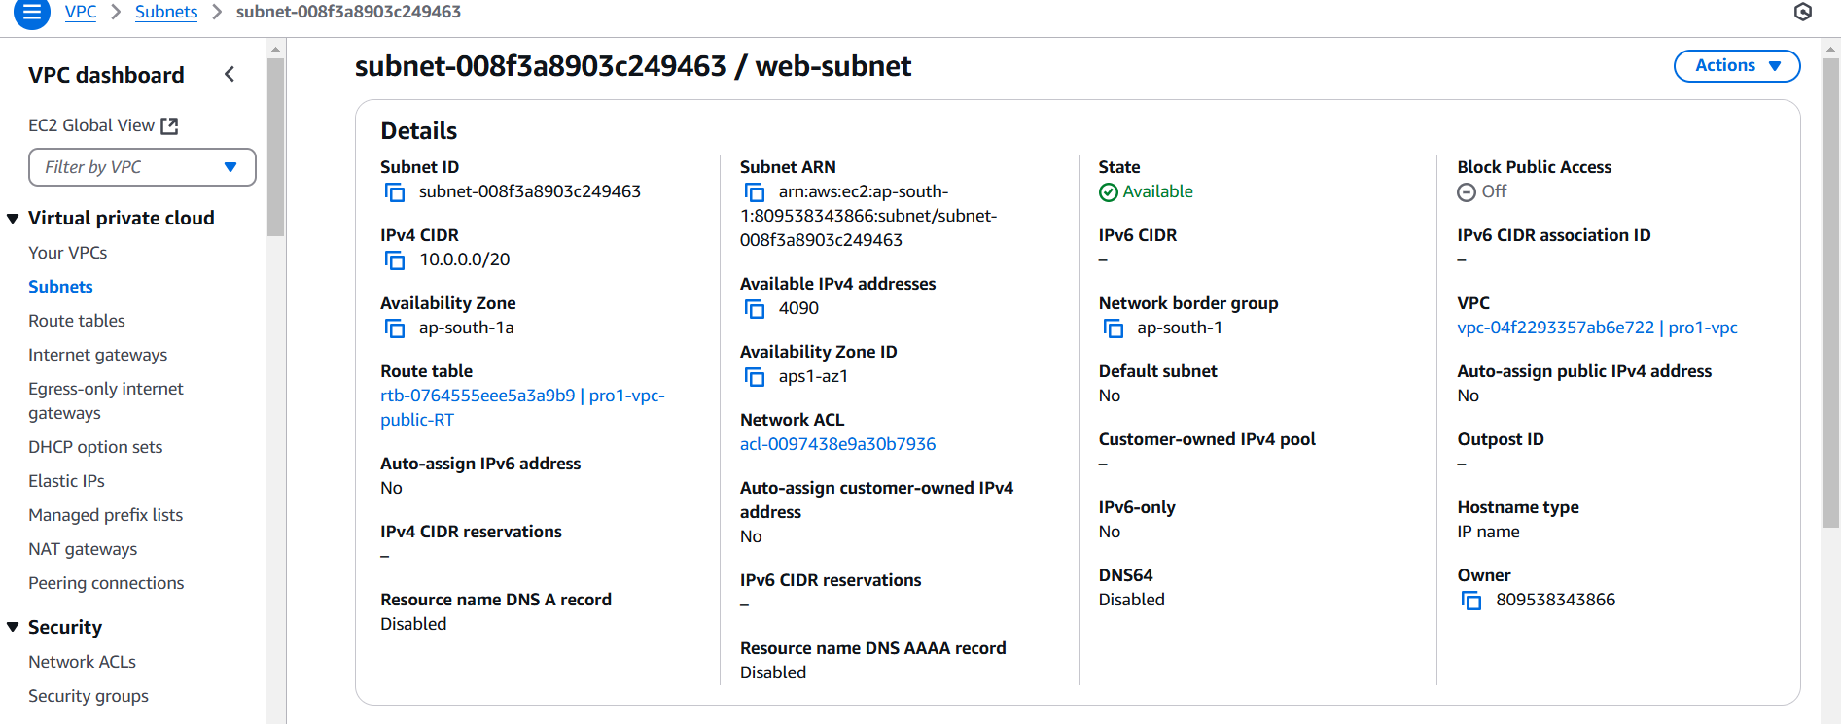

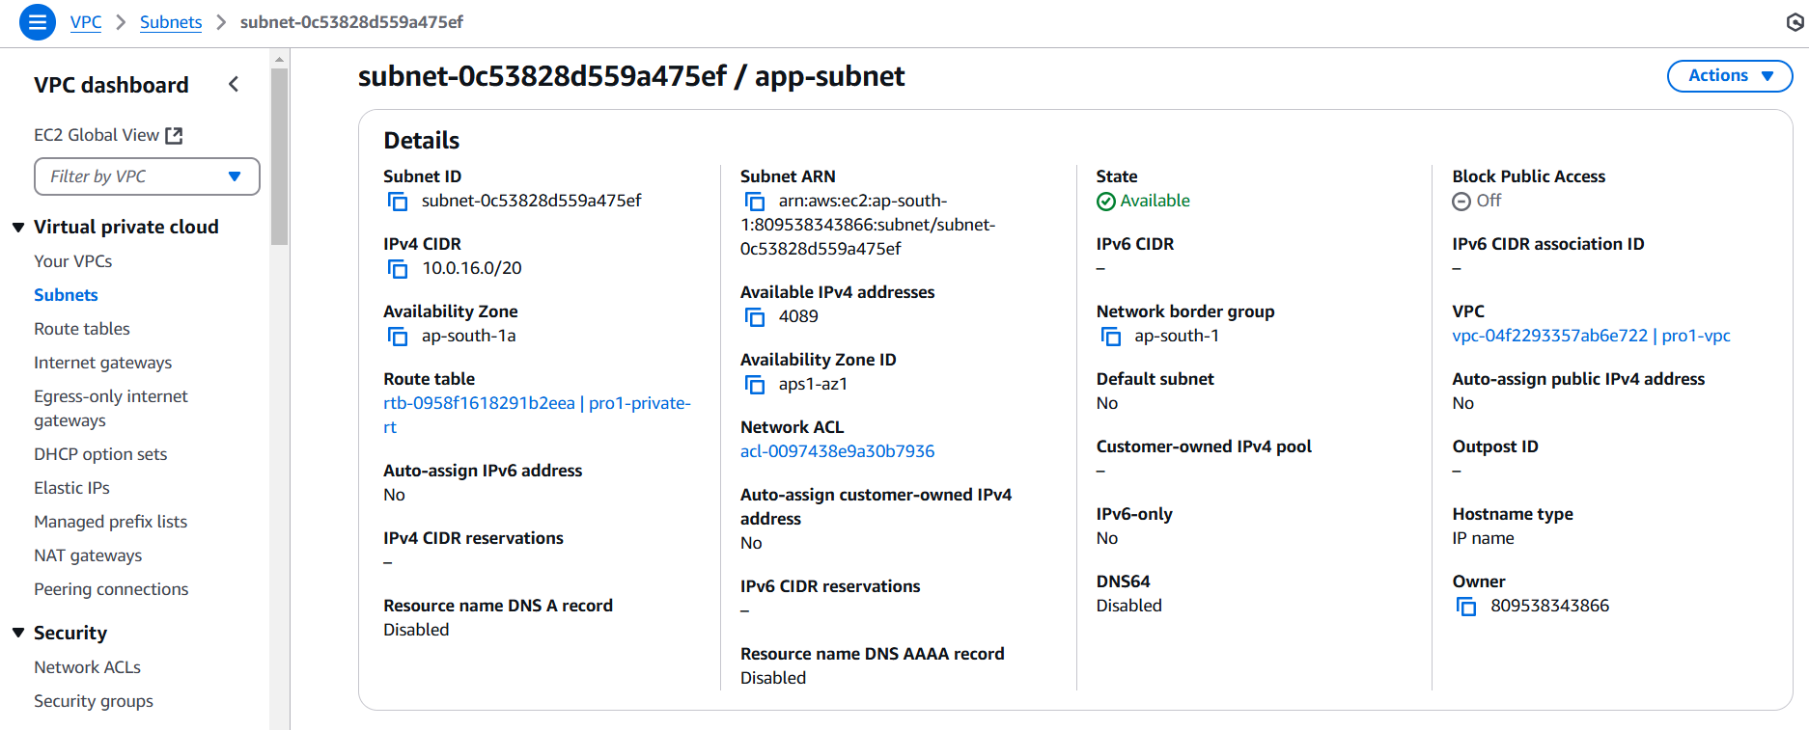

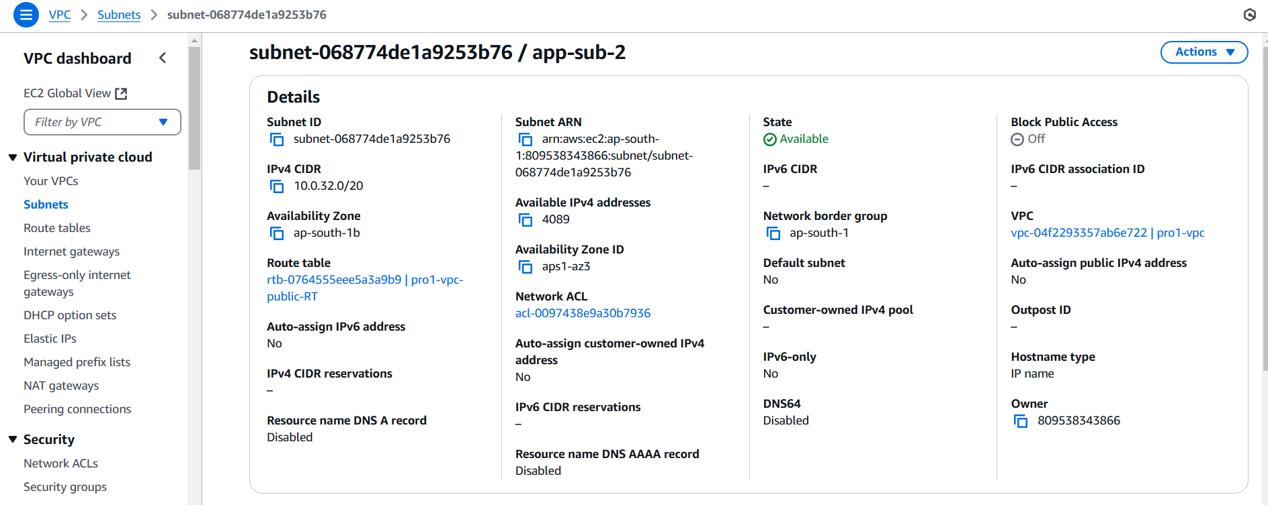

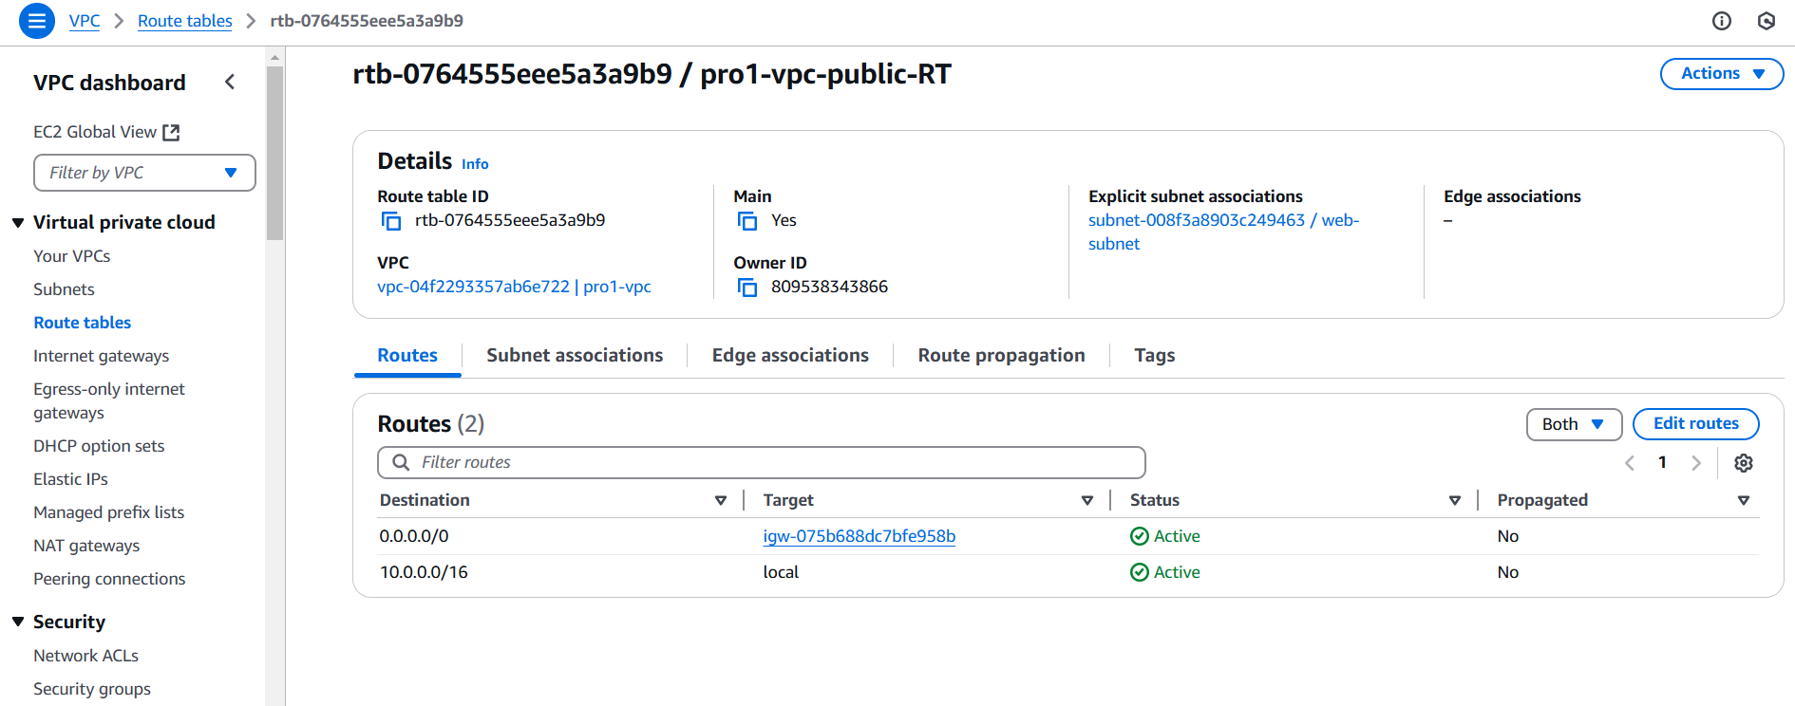

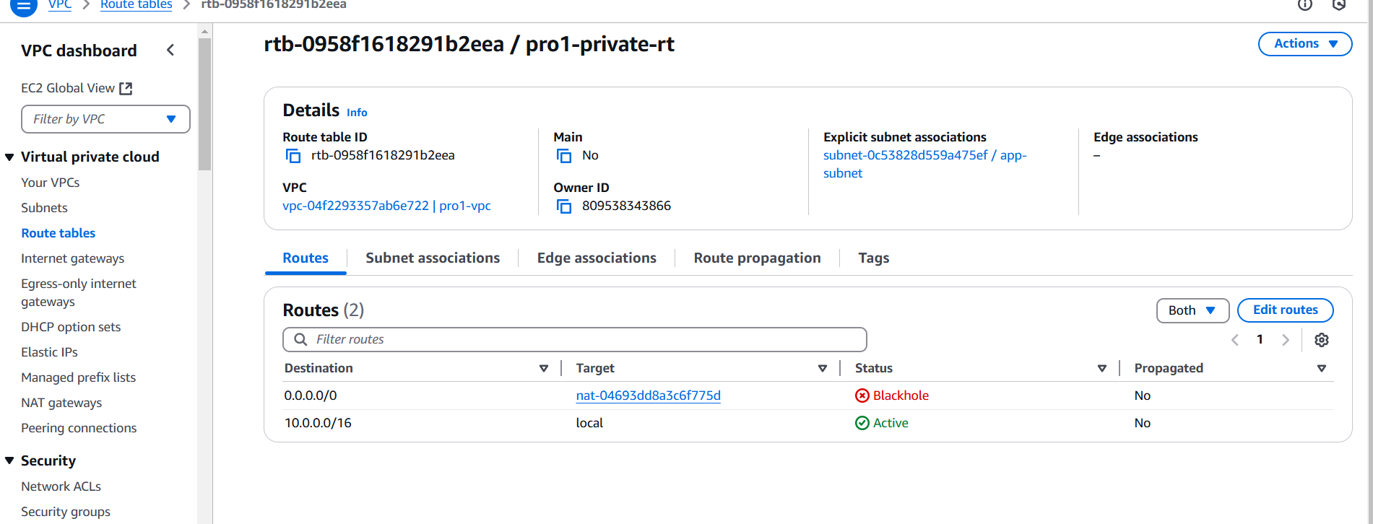

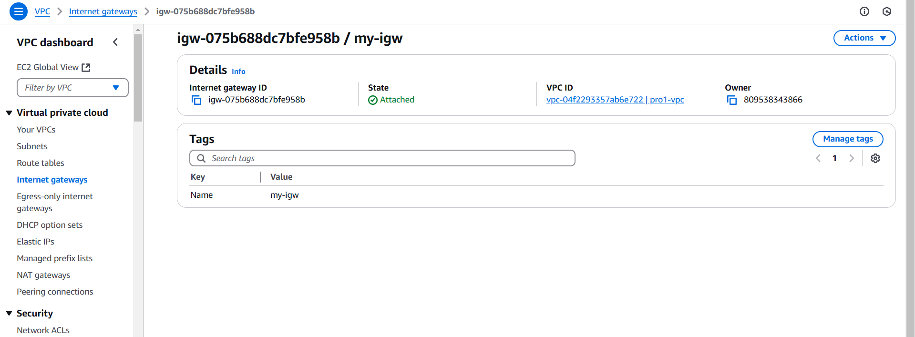

**--------------------------------------------------------------------------------------------------------------------------**

**Step 3. Web-Tier Instance**

**1] Launch and connect**

* Launch an Linux EC2 instance in the Web Subnet with public ip.
* Allow **SSH (22) & HTTP (80)** in Security Group.
* Connect to instance via SSH: ssh -i mykey.pem ec2-user@<public-ip>
* 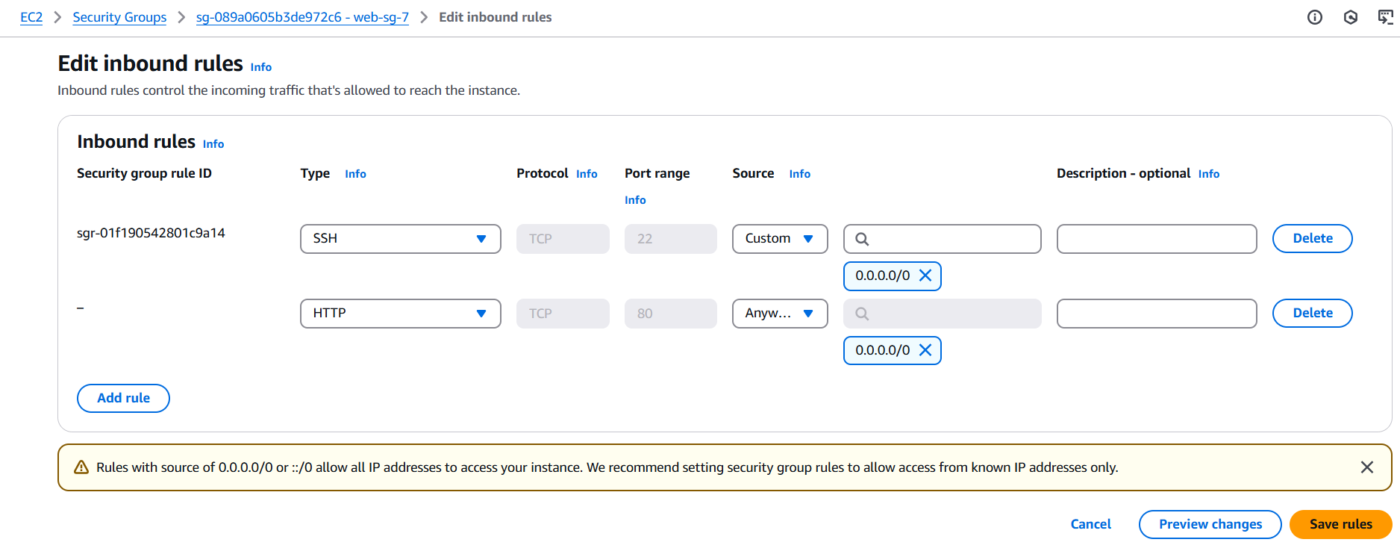

**2] Transfer App-tier instance private key & Install Software on Web-tier Instance**

* Send the **private key** to the web instance(Use laptop powershell )

scp -i mykey.pem myprivatekey.pem ec2-user@<public-ip>:.

* Install Nginx and MariaDB

sudo yum install nginx mariadb105-server -y

* Start & enable Nginx:

sudo service nginx start

sudo systemctl enable nginx.service

**3] Pass Proxy**

* Edit the Nginx configuration:

sudo nano /etc/nginx/nginx.conf

* Add proxy configuration:

location ~ \.php$ {

proxy_pass http://App-tier-ip;

}

* Restart Nginx:

sudo service nginx restart

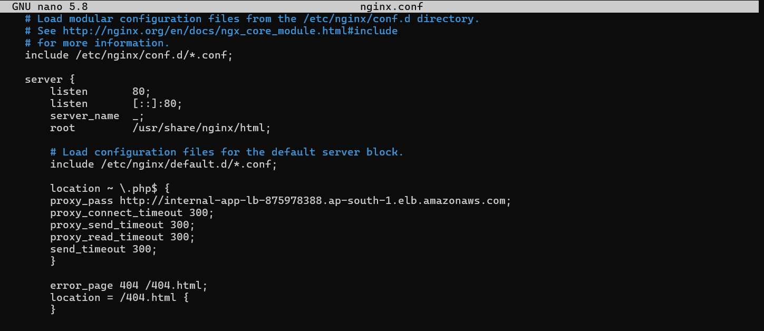

**4] Add Form Page**

* Create an HTML form in /usr/share/nginx/html/:

sudo nano /usr/share/nginx/html/form.html

* Sample form.html:

<form action="submit.php" method="post">

<input type="text" name="username" placeholder="Enter your name" required>

<input type="submit" value="Submit">

</form>

**--------------------------------------------------------------------------------------------------------------------------**

**Step 4. App-Tier Instance**

**1] Setup NAT Gateway for Private Instance Access**

* Create a **NAT Gateway** in **Web Subnet**.
* Update **Private Route Table**:
  + Add route: 0.0.0.0/0 -> NAT Gateway.

**2] Connect to Private Instance via Web Instance and Install softwares**

* Connect from Web to Private instance:

Sudo ssh -i myprivatekey.pem ec2-user@<private-ip>

* Install required packages:

sudo yum install nginx php mariadb105-server php8.3-mysqlnd.x86_64 -y

* Start & enable services:

sudo service nginx start

sudo service php-fpm start

sudo systemctl enable nginx.service

sudo systemctl enable php-fpm.service

**3] Add Submit.php page**

* Create submit.php in /usr/share/nginx/html/:

sudo nano /usr/share/nginx/html/submit.php

**4]** **Update Security Group**

Allow **HTTP (80)** add Web-Tier SG.

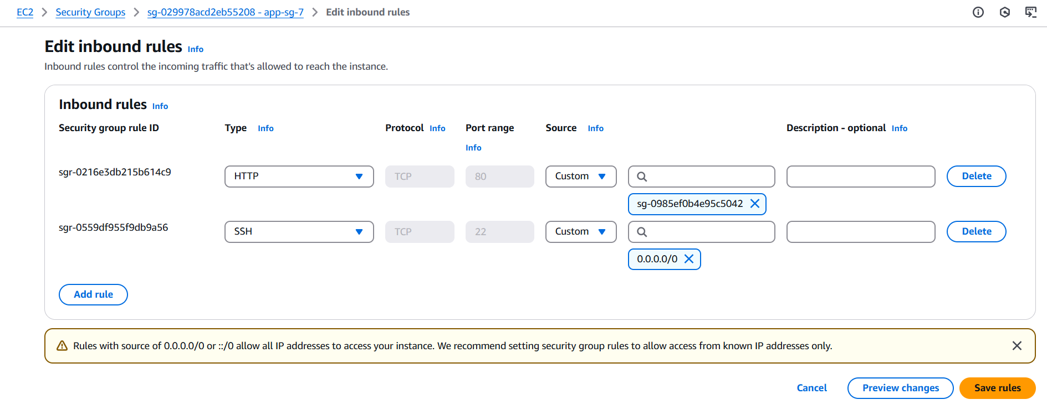

**--------------------------------------------------------------------------------------------------------------------------**

**Step 5. Setup RDS Database**

* Create an **RDS database** with **two private subnets** and Choose **mysql** engine.
* Allow MYSQL **3306** in SG for **Web-Tier sg & App-Tier** sg.

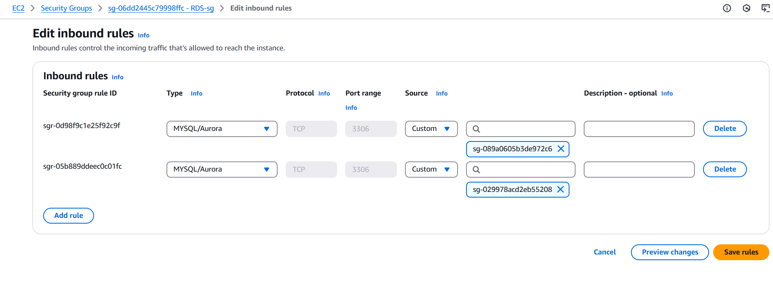

* Connect to RDS from Web instance:

Sudo mysql -h rds-endpoint -u username -p

* Create Database and Table:

CREATE DATABASE mydb;

USE mydb;

CREATE TABLE users (id INT AUTO_INCREMENT PRIMARY KEY, name VARCHAR(255));

**--------------------------------------------------------------------------------------------------------------------------**

**Step 6. Update Submit.php present at app-tier instance**

Add username , password and servername 🡪 endpoint of RDS database

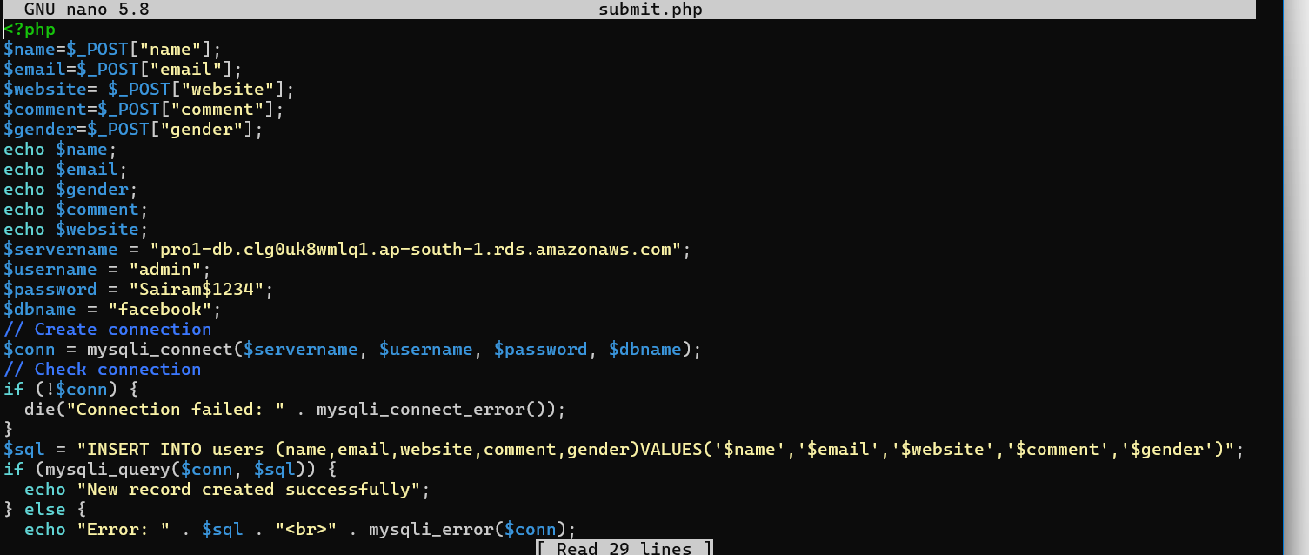

**-------------------------------------------------------------------------------------------------------------------------**

**Step 7. Create and add Load Balancer**

**1] Internal Load Balancer**

**1. Load Balancer**

* Create an **Internal Load Balancer**.

Add **App-Tier Instance** to the **Target Group**.

* Update **Security Groups**:
  + Add **Web-Tier SG** to **Load Balancer SG** (**HTTP 80**).
  + Add **Load Balancer SG** to **App-Tier SG** (**HTTP 80**).

**2. Update nginx.conf on Web-Tier:**

sudo nano /etc/nginx/nginx.conf

location ~ \.php$ {

proxy_pass http://<load-balancer-dns>;

}

* Restart Nginx:

sudo service nginx restart

**2] External Load Balancer**

* Create an **Internet-facing Load Balancer**.

Add **Web-Tier Instance** to the **Target Group**.

* Update **Security Groups**:
  + Add **Anywhere** to **Load Balancer SG** (**HTTP 80**).
  + Add **Load Balancer SG** to **Web-Tier SG** (**HTTP 80**).

------------------------------------------------------------------------------------------------------------------------

**Step 8. Final Checking Steps**

* Access http://<web-tier-public-ip>/form.html.
* Fill the form and submit.
* Check RDS database for stored data:

SELECT * FROM users;

